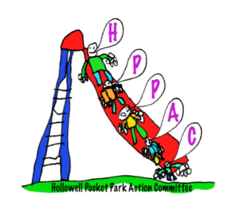

**HPPAC Chair Report**

**2021/22**

The HPPAC Committee threw itself into the running of the third Hollowell FAFF (fete and flower festival), running various fete stalls including the Nerf Gun Range, the Pimms stall and bar, Beat the Goalie stand, the village art and craft competitions and provided leadership, co-ordination and support for the whole event. Funds raised were divided equally between the Village Hall, Church and HPPAC and we were pleased to bank £2,477 from the proceeds.

The 2 additional picnic tables have now been installed in the park, increasing seating for families. These were acquired with no additional costs following a previous incorrect delivery.

In early 2022 we were asked by the Parish Council if we could assist with the cost of replacing the old double swing frame in the Pocket Park; the legs of the old frame having become rotten. We were pleased to be able to donate the sum of £3,041 towards the cost of the new frame and the installation of grass safety matting around this piece of equipment.

Hollowell Pocket Park continues to be a very well-used and popular local amenity. Neighbouring parks, including Guilsborough are looking to develop their own pocket parks based on the success (and equipment range) of Hollowell. Families from neighbouring villages often use Hollowell Pocket Park to meet, play and host birthday parties!! Impact of increased use and play means that some of the equipment, particularly the platforms of the scatter log multi-play kit is showing some signs of wear and tear on the wooden walkway. This is something that will need monitoring for the future.

We continue as a committee of 4, myself as Chair, Emily Curtis (Treasurer), Hannah Oswin (Secretary) and our committee member Dawn Fountain.

Continued thanks, as always to the residents of Hollowell and the Parish Council for their continued support.



**Julia Green**

**HPPAC Chair**